
EVENT: Mental Elf Festive Fun Run
DATE: 30th November 2025

Please sponsor me (name) ………………………………………to take part in Mental Elf in aid of Brecon and District Mind.

If I have ticked the box headed ‘Gift Aid’, I confirm that I am UK Income or Capital Gains tax payer. I have read this statement and want Brecon and District Mind to reclaim tax on the donation detailed below, given on the date shown. I understand that if I pay less Income Tax / or Capital Gains tax in the current year than the amount of Gift Aid claimed on all of my donations it is my responsibility to pay any difference. I understand the charity will reclaim 25p of tax on every £1 that I have given.
Remember: you MUST provide only one full name (taxpayers name), home address, postcode and ‘’ Gift Aid for the Brecon and District Mind to claim tax back on your donation.

 | Sponsor’s Full Name  (First name & Surname) | Sponsor’s Home Address  Only needed if you are Gift Aiding your donation  Do not give your work address for Gift Aid purposes. | Postcode | Donation Amount  £ | Date paid | Gift Aid
1
2
3
4
5
6
7
8

9

10

11
12
13
14
15

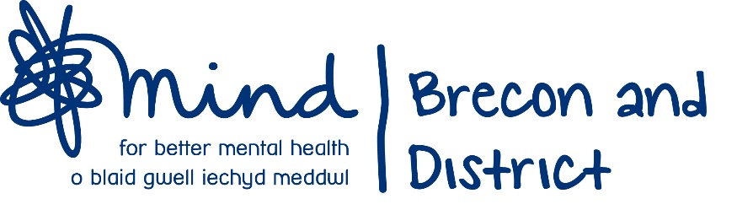
 |  | Total Gift Aid donations | £
Date donations given to
Brecon and District MIND

Brecon and District Mind, Tŷ Croeso, St David’s House, 48 Free Street, Brecon LD3 7BN
Tel: 01874 611529
Email: info@breconmind.org.uk
Website: www.breconmind.org.uk



