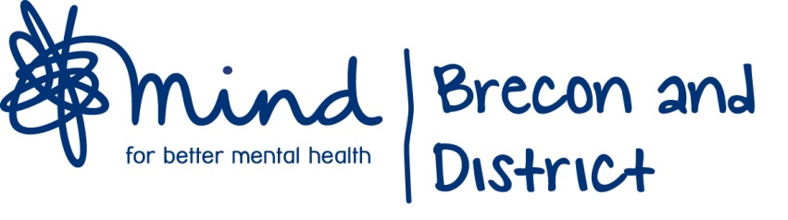

JOB ADVERT

Brecon and District Mind supports people in the community affected by mental health issues and emotional distress.
We are looking for an additional person to join our Community Well-Being Team, based at our Well-Being Centre in Brecon. You will be enthusiastic and well-motivated. You will have demonstrable experience of supporting people with Mental Health issues, be an effective communicator and have excellent interpersonal skills.
Post –Community Well-Being Worker
Hours – 16
Salary - £18,870 pro rata
Contract – Fixed term to March 2019 subject to further funding
Location – Brecon and outreach centres
Closing date for applications– Friday 24th August 2018
How to apply: - Telephone Michael Power or Val Walker 01874 611529
E-Mail info@breconmind.org.uk
Website www.breconmind.org.uk
Applications and job descriptions are available on the website to download

